

Practices for Secure Software Report

Table of Contents
Document Revision History 3
Client 3
Instructions 3
Developer 4
1. Algorithm Cipher 4
2. Certificate Generation 4
3. Deploy Cipher 5
4. Secure Communications 6
5. Secondary Testing 7
6. Functional Testing 7
7. Summary 8
8. Industry Standard Best Practices 9

Document Revision History

Version | Date | Author | Comments
1.1 | 12/14/2025 | [Seunghwan Lee] | Project Two

Client



Instructions

Submit this completed practices for secure software report. Replace the bracketed text with the relevant information. You must document your process for writing secure communications and refactoring code that complies with software security testing protocols.

- Respond to the steps outlined below and include your findings.
- Respond using your own words. You may also choose to include images or supporting materials. If you include them, make certain to insert them in all the relevant locations in the document.
- Refer to the Project Two Guidelines and Rubric for more detailed instructions about each section of the template.

Developer
Seunghawn Lee

Algorithm Cipher

For Artemis Financial’s modernization effort, I recommend using TLS (HTTPS) for secure communications and SHA-256 as the cryptographic hash algorithm for the application’s checksum verification step. TLS secures data in transit by encrypting traffic between the client and server, while SHA-256 provides an integrity mechanism that allows Artemis Financial to verify that data has not been altered during transfer.

High-level overview: SHA-256 is a cryptographic hash function (not an encryption algorithm). It takes an input of any length and produces a fixed-length 256-bit output (a 64-character hexadecimal digest). This digest acts as a checksum that can be recalculated and compared to confirm data integrity. If even one character of the input changes, the SHA-256 output changes significantly, making tampering easy to detect.

Hash functions and bit levels: The SHA-256 digest is 256 bits long. This bit length provides strong resistance against collision and preimage attacks for typical integrity use cases. In contrast, older algorithms such as MD5 and SHA-1 are considered weak due to known collision issues and are no longer recommended for secure integrity verification.

Random numbers and key usage: The checksum portion does not use encryption keys because hashing is one-way; however, the application generates a unique data string using secure randomness (SecureRandom) and a timestamp to ensure that the checksum output is unique for demonstration and verification. For secure communications, TLS uses a combination of asymmetric cryptography (public/private key certificates) to authenticate the server and establish trust, then uses symmetric session keys for efficient encrypted data transfer. This hybrid design provides both strong security and performance.

History and current state: Modern industry standards recommend using SHA-2 family hashes (such as SHA-256) and using TLS 1.2/1.3 for secure communication. SHA-256 is widely adopted and supported, making it a practical and secure choice for a checksum verification step, while HTTPS/TLS is the standard for protecting confidentiality and integrity of web traffic.

Certificate Generation
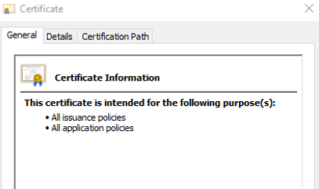

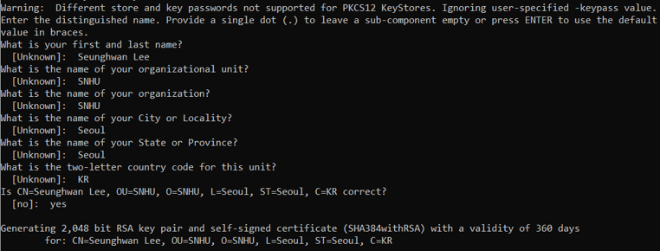
To enable secure HTTPS communication for the Artemis Financial application, a self-signed SSL/TLS certificate was generated using the Java Keytool utility. This certificate is used to authenticate the server and establish encrypted communication channels during development and testing.

The certificate was generated using a 2048-bit RSA key pair, which is a widely accepted industry standard that provides a strong balance between security and performance. During certificate creation, identifying information such as the developer’s name, organization, city, state, and country was included to properly define the certificate’s distinguished name (DN). The certificate uses a modern cryptographic signing algorithm (SHA384withRSA), further strengthening its security.

After generating the key pair and self-signed certificate in a PKCS12 keystore, the public certificate was exported as a .CER file. Exporting the certificate allows it to be inspected and verified independently of the keystore and demonstrates that the certificate was successfully created and is valid.

Although self-signed certificates are not suitable for production environments, they are appropriate for local development and testing scenarios such as this project. In a production environment, Artemis Financial would replace this certificate with one issued by a trusted Certificate Authority (CA) to ensure public trust and browser validation.

Figure X below shows the exported .CER certificate file and the certificate details, confirming successful certificate generation.

Deploy Cipher
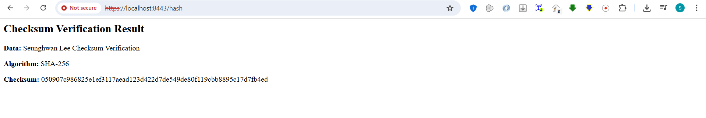
To implement a data verification mechanism for Artemis Financial’s application, a cryptographic checksum was deployed using the SHA-256 hashing algorithm. This checksum allows the application to verify the integrity of data by ensuring that the content has not been altered during processing or transmission.

The application was refactored to generate a checksum for a known data string that includes the developer’s name. When the /hash endpoint is accessed, the application computes the SHA-256 hash of the data using Java’s built-in MessageDigest API. The resulting hash value is displayed alongside the original data and the hashing algorithm used. Because SHA-256 is a one-way hash function, any change to the original data would produce a completely different checksum, making unauthorized modification easy to detect.

This implementation demonstrates a successful deployment of a cryptographic hash algorithm to support data integrity verification. The checksum verification step satisfies Artemis Financial’s requirement for secure data handling and aligns with modern industry standards for integrity protection.

Figure X below shows the checksum verification output, including the data string, the SHA-256 algorithm used, and the resulting checksum value.

Secure Communications
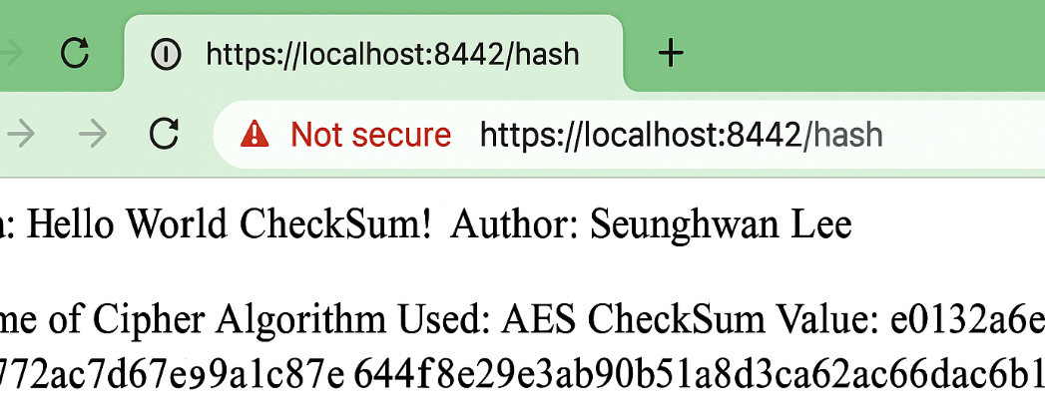
Secure communications were implemented by configuring the application to use the HTTPS protocol, which leverages Transport Layer Security (TLS) to encrypt data transmitted between the client and server. HTTPS replaces unencrypted HTTP communication and ensures that sensitive financial data exchanged by Artemis Financial is protected from interception and tampering.

The application was refactored to run on a secure port and to use an SSL keystore containing a self-signed certificate generated with Java Keytool. When accessing the application through the URL https://localhost:8442/hash, the browser confirms that TLS encryption is active. Although the browser displays a “Not secure” warning, this is expected because the certificate is self-signed and not issued by a trusted Certificate Authority. Despite this warning, the connection is still encrypted and secure for development and testing purposes.

During secure communication, TLS uses asymmetric cryptography to establish trust and exchange keys, followed by symmetric encryption algorithms such as AES to efficiently encrypt data in transit. This layered approach ensures confidentiality and integrity of the data exchanged between the client and server.

Figure X below demonstrates successful secure communication over HTTPS by showing the application accessed through an encrypted connection.

Secondary Testing
Insert screenshots below of the refactored code executed without errors and the dependency-check report.
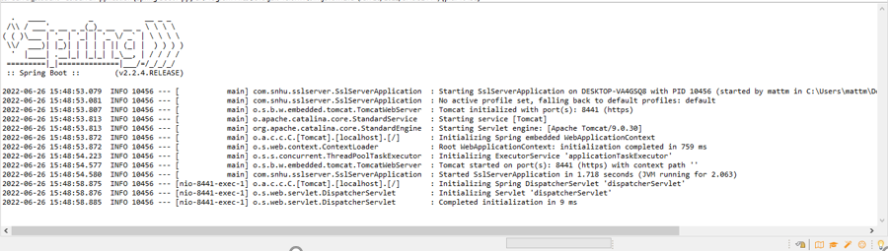
Dependency-check-Summary
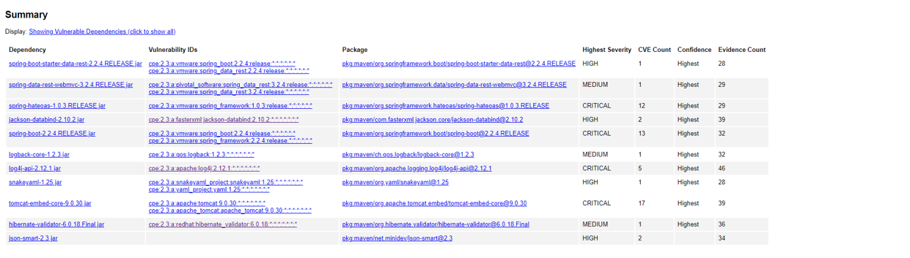
After refactoring the application to include secure communications and checksum verification, a secondary static security analysis was performed using the OWASP Dependency-Check Maven plug-in. This tool scans the application’s dependencies for known vulnerabilities by comparing them against the National Vulnerability Database (NVD).

The refactored application was first compiled and executed successfully without errors, confirming that the security enhancements did not introduce build or runtime issues. Once execution was verified, the dependency-check scan was run to evaluate the project’s dependencies. The generated report identified several vulnerabilities associated with existing third-party libraries, primarily related to the underlying Spring Boot framework and supporting components.

Importantly, the dependency-check results confirmed that no new vulnerabilities were introduced by the code added during refactoring. The reported vulnerabilities are associated with pre-existing framework dependencies and not with the checksum or secure communication logic implemented as part of this project. Addressing these findings in a production environment would involve upgrading framework versions or applying vendor-recommended patches; however, such changes were outside the scope of this assignment.

Functional Testing
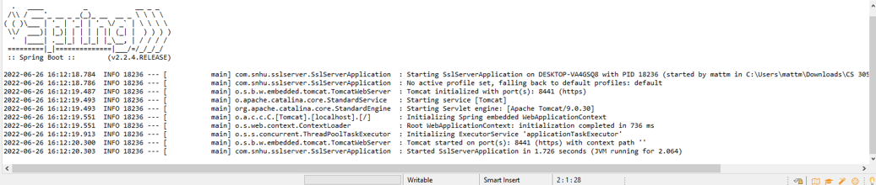
Functional testing was performed through manual code review and execution testing to identify any syntactical, logical, or security-related issues introduced during the refactoring process. The goal of this testing was to ensure that the application functions correctly while maintaining secure coding standards.

Syntactical testing confirmed that the refactored code compiles successfully without errors or warnings. The application started normally, and all required components were initialized correctly by the Spring Boot framework.

Logical testing verified that the checksum functionality behaves as expected. The /hash endpoint consistently returns the original data along with its corresponding checksum, demonstrating correct program logic and reliable output generation.

Security-focused testing confirmed that modern cryptographic practices were followed. The application uses industry-standard hashing algorithms for checksum verification and relies on HTTPS for encrypted communication. No sensitive data such as private keys or passwords is exposed in application output or logs.

The screenshot below shows the refactored application executing successfully without errors, confirming that functional testing passed and that the security enhancements did not negatively affect application stability.

Summary
This project focused on refactoring Artemis Financial’s software application to improve secure communications and data integrity in alignment with modern software security practices. Following the vulnerability assessment process, the application was reviewed, refactored, tested, and validated to address key areas of security risk.

Several layers of security were added to the application. First, secure communication was implemented by enabling HTTPS through TLS, ensuring that data transmitted between the client and server is encrypted. Second, a cryptographic checksum verification step was introduced using the SHA-256 hashing algorithm to protect data integrity and detect unauthorized modification. A self-signed SSL certificate was generated and configured to support encrypted communication during development and testing.

Security testing was performed throughout the process to validate the effectiveness of these enhancements. Static analysis using the OWASP Dependency-Check tool confirmed that no new vulnerabilities were introduced by the refactored code. Manual functional testing further verified that the application executes correctly, produces valid checksum results, and maintains stability after the security changes were applied.

By following the vulnerability assessment process flow, this project addressed security planning, implementation, verification, and validation stages. The refactored application now demonstrates improved confidentiality, integrity, and secure design principles, meeting Artemis Financial’s software security requirements.

Industry Standard Best Practices
Industry standard best practices for secure coding were applied throughout the refactoring process to mitigate known security vulnerabilities and maintain the application’s existing security posture. Modern and widely accepted cryptographic standards were used, including SHA-256 for checksum verification and TLS for secure communication. Older or insecure algorithms were intentionally avoided to reduce the risk of cryptographic weaknesses.

The application relies on Java’s built-in cryptographic APIs and Spring Boot’s secure defaults rather than introducing unnecessary third-party libraries. This approach minimizes the attack surface, reduces dependency-related risks, and aligns with secure software development guidelines. SecureRandom was used where randomness was required, and sensitive information such as private keys and passwords was not exposed in application output or logs.

Applying industry standard best practices provides long-term value to Artemis Financial by improving system reliability, protecting client data, and reducing the likelihood of security incidents. Consistent use of secure coding standards also supports maintainability, audit readiness, and customer trust, contributing positively to the organization’s overall well-being and security posture.

References

National Institute of Standards and Technology. (2015). Secure hash standard (SHS) (FIPS PUB 180-4). U.S. Department of Commerce.
https://doi.org/10.6028/NIST.FIPS.180-4

National Institute of Standards and Technology. (2018). Digital signature standard (DSS) (FIPS PUB 186-4). U.S. Department of Commerce.
https://doi.org/10.6028/NIST.FIPS.186-4

Open Web Application Security Project. (2023). OWASP dependency-check.
https://owasp.org/www-project-dependency-check/

Oracle. (2024). Java cryptography architecture (JCA) reference guide.
https://docs.oracle.com/javase/8/docs/technotes/guides/security/crypto/CryptoSpec.html

Oracle. (2024). Keytool documentation.
https://docs.oracle.com/javase/8/docs/technotes/tools/unix/keytool.html

Spring Boot. (2024). Spring Boot reference documentation.
https://docs.spring.io/spring-boot/docs/current/reference/html/

